**PROJECT**

**NAME:** Ikem Mercy Ogechi

**STUDENT ID:** 8859960

**COURSE CODE:** INFO8491-23W

**PROFESSOR NAME:** Dr. Zara Hamid

**DUE DATE:** 16th April,2023.

Contents

SITE A 2

DESCRIPTION: 2

REQUIREMENTS: 2

DESIGN 2

IP ADDRESS ASSIGNMENT: 2

SCREENSHOT 2

SITE B 2

DESCRIPTION: 2

REQUIREMENTS: 2

DESIGN 2

SCREENSHOT 2

SITE C 2

DESCRIPTION: 2

REQUIREMENTS: 2

DESIGN 2

SCREENSHOT 2

# SITE A

# DESCRIPTION:

Site A goal is to design and deploy a trustworthy network for a company using three layer 2 switches and two routers. The network requires a web server with a customized homepage, secure authentication, and EIGRP without auto-summary for routing updates between the access router and the edge router. For remote SSH connection to the access router and the edge router, a TACACS server is what I will use based on what I have been taught in this course.

# REQUIREMENTS:

* A network design that is both secure and efficient
* Web server with personalized home page
* Secure authentication and encryption must be used for routing updates between the access router and edge router.
* EIGRP without auto summary
* Remote SSH login to access and edge routers must use TACACS server authentication.
* Three layer 2 switches connected to each other without causing network loops.
* A single IP address with a /28 CIDR will be used for the entire network.
* My subnet **10.150.136.0/28**
* The IP address between edge access and access router will be 10.150.136.48/28.

# DESIGN

* **I will use 2 PT servers, 3-2960 layer 2 switches, 1- cisco 2911 Router, 1 Router PT router for this site.**
* I will use EIGRP for routing between the access router and edge router. Loopback addresses will be used for EIGRP updates.
* I will configure Vlan 1
* TACACS server will also be configured on this network to handle remote SSH login authentication for the access router and the edge router.
* I will configure a custom home page for my web server, I will activate the DNS service.
* STP will be configured on all switches to prevent network loops. SW2 will be configured as the root bridge, SW1 will have a root port on the interface connecting to SW2, and SW3 will have a root port on the interface connecting to SW1. All interfaces will be designated ports.
* I will connect the edge router in SITE A to SITE b using daisy chain manner which will also be connected to SITE C.

**IP ADDRESS ASSIGNMENT:**

* SW1: 10.150.136.2/28
* SW2: 10.150.136.3/28
* SW3: 10.150.136.4/28
* **Access Router:**
* LAN: 10.150.136.1/28
* WAN: 10.150.136.49/28
* **Edge Router:**
* LAN: 10.150.136.50/28
* WAN: 10.150.136.160/28
* Tacacs server: 10.150.136.5/28
* Web server: 10.150.136.6/28

# SCREENSHOT

fig1 showing my topology showing different sites.

Fig 2 showing that this is the root bridge, designated ports, and ports costs on switch 3. The ports cost 19.

Fig 3 showing the blocking ports, designated ports and ports cost is 19 on Switch 1.

Fig 4 showing the designated ports and ports cost 19 on switch 2.

Fig 5 showing my customized home page.

Fig 6 showing that I have configured banner of the day and I have enforced login.

Fig 7 showing that I am using tacacs authentication for my access router and edge router.

Fig 8 showing the configuration I made on my waterloo access router.

Fig 9 showing the running configuration I made on access router.

Fig 10 showing the configuration I made on the access router.

Fig 11 showing that the pc in site b can communicate with the router, switch and the server in site A.

Fig 12 shows that site c can communicate with site A.

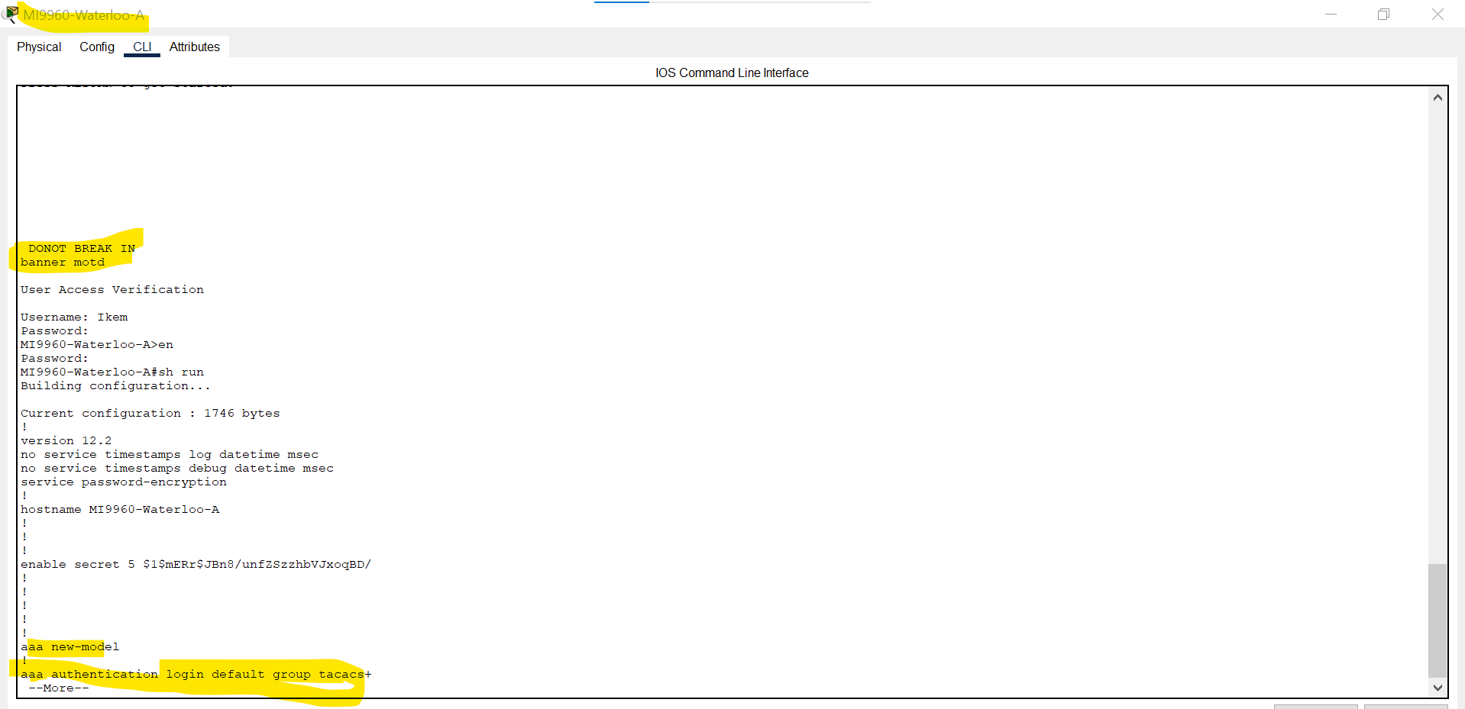

Fig 13 showing the configuration I made on the edge router.

Fig 14 showing the configuration I made on the edge router.

Fig 15 showing the configuration I made on the edge router.

Fig 16 showing that I can ssh into the access router in site A using the pc in site b

Fig 17 showing that I ssh into the edge router on site A using the pc in site b.

Fig 18 showing my Topology for site A.

# SITE B

# DESCRIPTION:

The goal for site B is to create a network that contains several switches, routers, and PCs that must be connected to provide secure remote access, inter-VLAN routing, and device connectivity.

# REQUIREMENTS:

I will configure site B to do the following.

* I will configure the access router and edge router to authenticate using RADIUS server and remote using ssh.
* The radius server will be connected to one of the Vlans.
* Each of my switches in site b will have two identical vlans.
* Two pcs will be connected to each of the layer 2 switches, and they will be on separate vlans.
* I will connect the two-layer 2 switch to a layer 3 switch and configure VLAN Trunking and Inter VLAN routing.
* The computer connected to the switch must be able to communicate with each other.

# DESIGN

To meet the requirements I mentioned above, I must make sure that my design will be implemented like this:

* My network will have several devices, including switches, routers, and computers. The network will have two VLANs, VLAN 10 and 20.
* The access router will be the default gateway for the switches and the PC.
* I will use OSPF authentication to route between my Access and Edge router. The Edge router will securely **redistribute** routing information between site A and site B.
* I will include the following devices.
* **Access router-** 1 2911 router
* **Edge router-** 1 router PT
* **Layer 3 switch -**1 3560-24PS
* **Two-layer 2 switch -**2960 Switches.
* **Radius server**
* **two pcs on both sides.**
* Access router will be connected to the edge router through serial link.
* The Edge router will be connected to layer 3 switch through a link and to the access router.
* I will connect the layer 3 switch to layer 2 switches through a trunk link.
* My radius server will be connected to one of my vlan (VLAN 10).
* My two PCs will be connected to the Vlans. (VLAN 10 and 20).

I will assign the following IP addresses to my devices.

* Access router-se9/0-10.150.136.162/28 gig6/0 10.150.136.66/28 se2/0 10.150.136.177/28
* Edge router- VLAN 10 (10.150.136.17/28) VLAN 20 (10.150.136.33/28)
* Layer 3 switch-VLAN 10 (10.150.136.21/28) VLAN 20 (10.150.136.37/28)
* MI9960-PC 1-10.150.136.19/28(VLAN 10)
* MI9960-PC 2-10.150.136.34/28(VLAN 20)
* MI9960-PC3-10.150.136.35/28(VLAN 20)
* MI9960-PC4-10.150.136.20/28(VLAN 10)
* Radius server-10.150.136.18/28(VLAN 10)

# SCREENSHOT

Fig 19 shows my Site B topology.

Fig 20 showing my vlan in switch 2 in site B.

Fig 21 shows my vlan in switch 1 in site B.

Fig 22 showing my vlan in my multilayer switch.

Fig 23 showing the configuration I made in my multilayer switch.

Fig 24 showing the configuration I did in MI9960 Access Router.

Fig 25 showing the configuration I did in MI9960 Access Router.

Fig 26 showing the configuration I did in MI9960 Access Router.

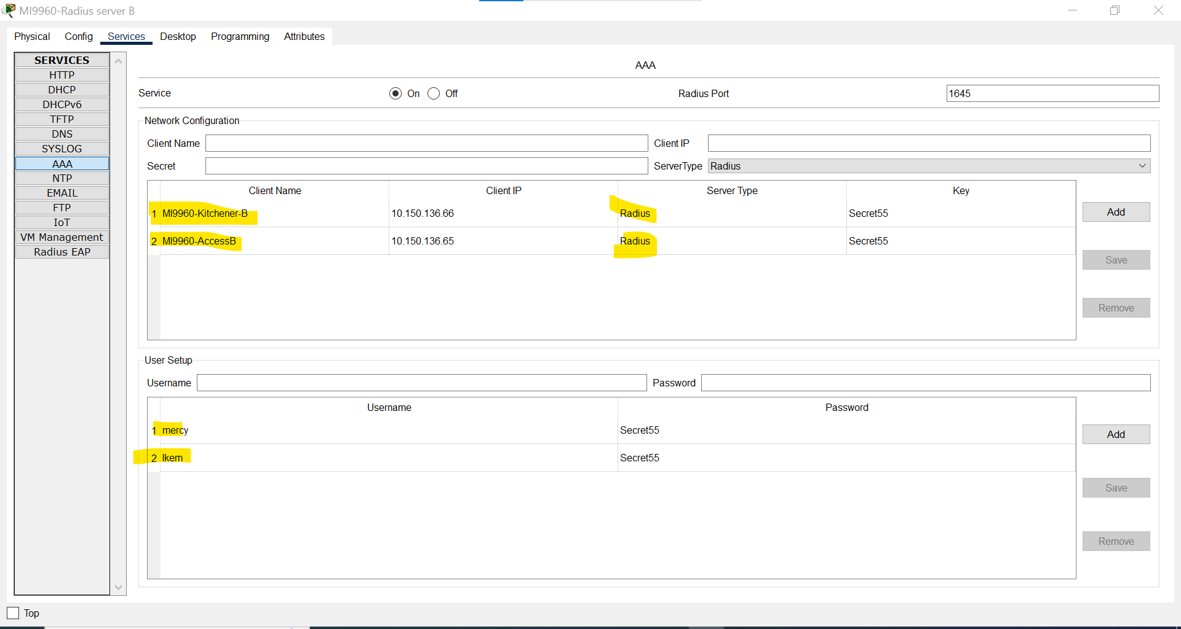

Fig 27 showing that I am using radius authentication for my access router and edge router.

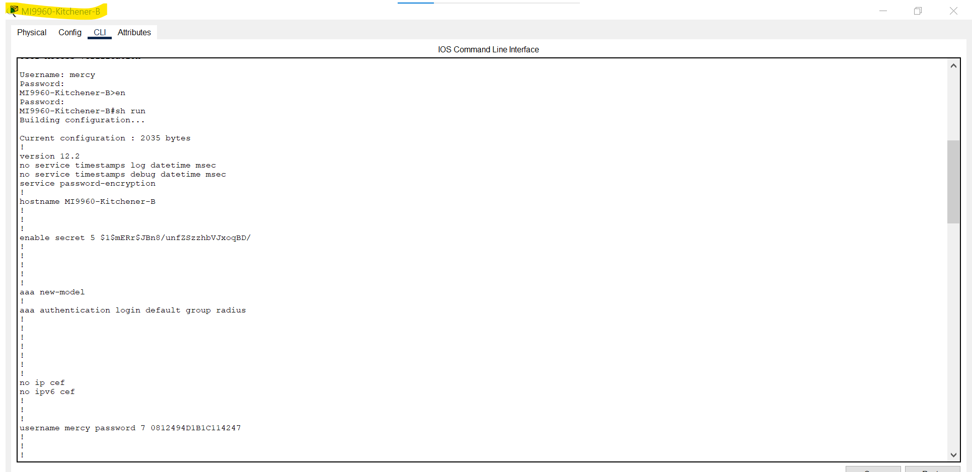

Fig 28 showing the configuration I made in my edge router.

Fig 29 showing the configuration I made in my edge router.

Fig 30 shows that my edge router is the main point for my redistribution to take place.

Fig 31 showing the configuration I made in my edge router.

# SITE C

# DESCRIPTION:

The aim for my site C is to design and implement a network infrastructure for a multi-site organization. I will include three different networks and subnets.

# REQUIREMENTS:

* I will ensure that all my computers can communicate with each other.
* I will ensure that all devices in the network can be remotely managed using local authentication.
* I will configure RIP routing protocol between Access and edge router.
* I will configure **redistribution** of routing information between site A and site C.
* I will configure local authentication on my network devices.

# DESIGN

* 1 router PT, 1 router PT, 3 PC-PT.
* My three computers will have their own subnets and they will be connected to the access router.
* The access router will be responsible for routing between the different networks. I will configure RIP routing protocol to communicate with the edge router.
* I will configure remote access using local authentication.
* I will use daisy chain connection for SITE C and SITE B.

IP Addressing

* MI9960-PC Guelph 1- 10.150.136.82/28
* MI9960-PC Guelph 2- 10.150.136.98/28
* MI9960-PC Guelph 3- 10.150.136.112/28
* MI9960-Access Guelph – gig4/0 10.150.136.81/28 gig5/0 10.150.136.97/28 gig6/0 10.150.136.113/28 gig7/0 10.150.136.130/28
* MI9960-Edge Guelph- gig6/0 10.150.136.129/28 se9/0 10.150.136.178/28

# SCREENSHOT

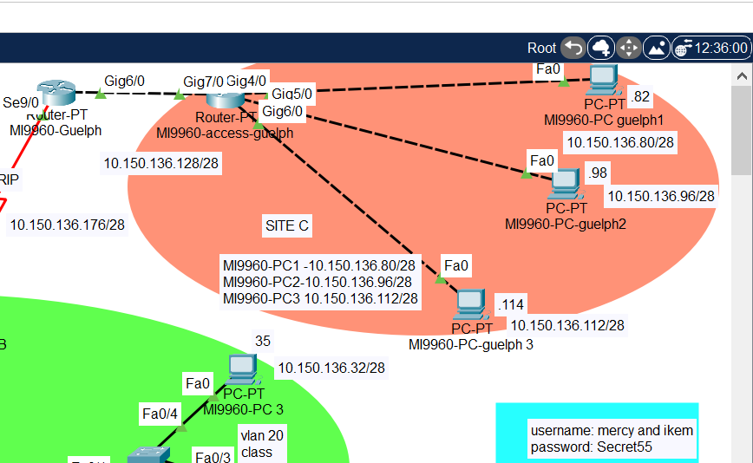

Fig 32 showing the topology for site C.

Fig 33 shows the configuration I made in my access router.

Fig 34 shows the configuration I made in my access router.

Fig 35 shows the configuration I made in my access router.

Fig 36 shows the configuration I made in my access router.

Fig 37 shows the configuration I made in my edge router.

Fig 38 shows the configuration I made in my edge router.

Fig 39 shows the configuration I made in my edge router.

Fig 37 showing that I can ssh into the edge router in site A